Annual Review of Education, Health and Care Plan

For children in Nursery to Year 6
Once an EHCP has been issued, a review of the EHC plan should take place on a least a termly basis and then each subsequent year, an Annual Review meeting will take place for those children and young people aged 5 onwards. For pre-school aged children, the EHCP should be reviewed every 3 to 6 months. Leicestershire County Council asks that schools, colleges and providers carry out the Annual Review process on their behalf.
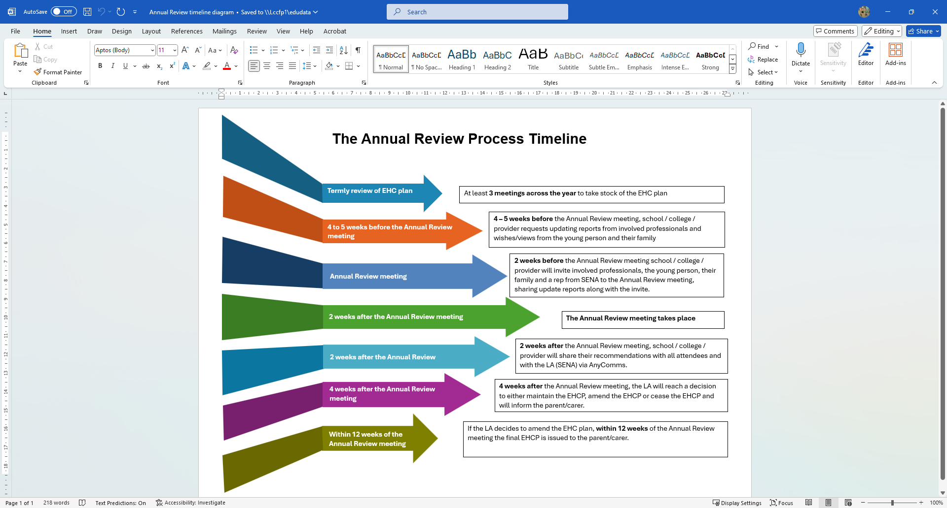

Significant periods for phase transfers (taken from SEND Code of practice):
Early years provider to school / Infant school to junior school / primary school to secondary school
- The review should be completed within the autumn term to enable the review and amendments to be completed by 15th February

Where to go to get reports for the Annual Review meeting

Action required | Associated document | Date
Health requesting schools to email: LPT.EHCAR@nhs.net | Health professional contribution to annual review (Word document) | 8 weeks prior to Annual Review meeting

What to do before the Annual Review meeting

Contributors to the review
When issuing invites to the review meeting all advice and information relevant to the current EHCP must be shared with attendees so that updates can be prepared and provided. Please indicate here what advice and information have been shared prior to the meeting and who provided updated information for this review.
Additional blank rows have been included to add in any additional roles that are providing advice / information.

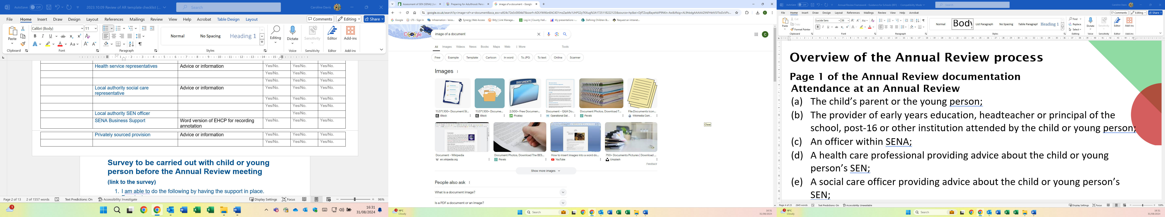Refer to Annual Review guidance document – pages 4 and 5
Name | ROLE  (Educational Psychologist,  Therapist, Child/Young Person,parent) | Information required | Advice or information requested | Invited to Annual Review meeting | Advice or information received  received
 | Child or Young person | Voice – One Page Profile (separate document) | Yes/No. | Yes/No. | Yes/No.
 | Parent/carer | Voice – separate proforma | Yes/No. | Yes/No. | Yes/No.
 | Educational setting | Costed provision map (if readily available – required for change of placement) | Yes/No. | Yes/No. | Yes/No.
 | Educational setting | Current EHCP in use | Yes/No. | Yes/No. | Yes/No.
 | Education representatives (include tutors) | Advice or information | Yes/No. | Yes/No. | Yes/No.
 | Educational setting | Record of attendance | Yes/No. | Yes/No. | Yes/No.
 | Educational setting | Individual Health Care Plan | Yes/No. | Yes/No. | Yes/No.
 |  |  | Yes/No. | Yes/No. | Yes/No.
 | Health service representatives | Advice or information | Yes/No. | Yes/No. | Yes/No.
 |  |  | Yes/No. | Yes/No. | Yes/No.
 |  |  | Yes/No. | Yes/No. | Yes/No.
 | Local authority social care representative | Advice or information from Family Help staff, e.g. SEND Family Support Workers, Keyworkers; Children’s Social Workers; Young Adult Disability Social Worker; Adult Social Worker | Yes/No. | Yes/No. | Yes/No.
 |  |  | Yes/No. | Yes/No. | Yes/No.
 |  |  | Yes/No. | Yes/No. | Yes/No.
 | Local authority SEN officer |  |  |  | Yes/No.
 | SENA Business Support | Word version of current final EHCP for recording annotation | Yes/No. | Yes/No. | Yes/No.
 | Privately sourced provision | Advice or information | Yes/No. | Yes/No. | Yes/No.
 |  |  | Yes/No. | Yes/No. | Yes/No.

Work prior to the Annual Review
Survey to be carried out with child or young person before the Annual Review meeting
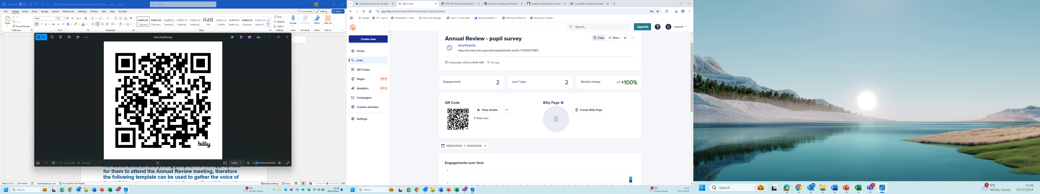 https://bit.ly/41aqV2p
Questions within the survey:
- What type of school do you go to?
- Primary school
- Secondary school
- Special school
- Other

- What does the support you have at school help you to do?
Free text

- How often, if at all, do you feel that you are getting the right support to help you at school?
All of the time Most of the time Some of the time Not very often Never Don’t know

- Is there anything else you would like to say about the support you have at school?
Free text.

This response was provided by the:
- Me – the child or young person
- A representative on behalf of the child or young person
N.B. This information is being used as part of the Accelerated Progress Plan and reporting on the SEND & Inclusion Strategy.

For some children and young people, it is not appropriate for them to attend the Annual Review meeting, therefore the following information / template can be used to gather the voice of the child prior to the meeting. It is good practice to share the contents along with other contributions at the Annual review meeting.
Refer to Annual Review guidance document – pages 8 to 10 plus information on Preparation for Adulthood page 15.
See One Page Profile for child – complete prior to Annual Review meeting

See proforma for parent/carer – complete prior to Annual Review meeting

During the Annual Review meeting
Name of School
Pupils Name
Date of Birth | Click or tap to enter a date. |  | Date of AR | Click or tap to enter a date.
Address
Year Group |  | N/C Year Group Educated

Looked After Child |  | Care Authority

Who attended the meeting?
Name | ROLE  (Educational Psychologist,  Therapist, Child/Young Person,parent) | Attended Yes / No
 | Child or Young person | Yes/No.
 | Parent/carer | Yes/No.
 | Setting, school, college representative | Yes/No.
 |  | Yes/No.
 | Education representative (include tutors) | Yes/No.
 |  | Yes/No.
 | Health service representative | Yes/No.
 | Local authority social care representative, e.g. Family Help – SEND Family Support Worker, Keyworker; Children’s Social Worker, Young Adult Disability Social Worker; Adult Social Worker | Yes/No.
 | Local authority SEN officer | Yes/No.
 | Privately sourced provision | Yes/No.
 |  | Yes/No.
Type of Annual Review
Scheduled Review ☐ Early Review ☐
Transition Review ☐ Updated Plan Following Tribunal ☐
Primary category of need (Taken from SEND Code of Practice)
Cognition & Learning ☐ Social Emotional and Mental Health ☐
Communication & Interaction ☐ Sensory and Physical ☐

Primary need (Taken from School Census)
Autism Spectrum Disorder ☐ Hearing Impairment ☐
Moderate Learning Difficulty ☐ Multi-sensory Impairment ☐
Other difficulty / disability ☐ Physical Disability ☐
Profound and Multiple Learning Difficulty ☐
Severe Learning Disability ☐
Social Emotional and Mental Health ☐ Specific Learning Difficulty ☐
Speech, Language or Communication Difficulty ☐ Visual Impairment ☐

Refer to Annual Review guidance document – page 9
If the child or young person contributed through alternative means, please include the method used:

If the child/young person did not attend or contribute to the review, please provide reasons why and what support has been provided to ensure their views have been gathered and included:

Recording the conversation
Refer to Annual Review guidance document – pages 7 and 8
Please note the key points discussed during the discussion in the note section.
Taken from the SEND Code of Practice:
9.177 The meeting must focus on the child or young person’s progress towards achieving the outcomes specified in the EHC plan, and on what changes might need to be made to the support provided to help them achieve those outcomes, or whether changes are needed to the outcomes themselves.
Also consider:
- Preparation for Adulthood (or the future)
- Aspirations – what I would like to achieve?
Refer to Annual Review guidance document – pages 7, 9 and 10
Section A - notes
Consider:
- Continued relevance of any historical / sensitive information.
- Contribution from the child / young person and parent/carer.
- Information that gives the views, interests and aspirations of the child/ young person and their parents/ carers – key points from the One Page Profile and the parent/carer proforma can be recorded in the section below

Capturing the voice of the child (the thread that runs through the EHCP)
This is what I want for my future:

This is how I would like to be supported

Capturing the Voice of Parent/carers:
This is what my parent/carers aspirations are for me in the future:

This is how my parent/carers will support me

Refer to Annual Review guidance document – pages 11 and 12
Notes on the discussion for sections: C & G, D & H1/H2 (health and care sections)
It is helpful to record:
- Where there is agreement
- Where there is disagreement
- Where the disagreement has been resolved
- Where the disagreement has not been resolved

Refer to Annual Review guidance document – pages 13, 14 and 15
Section E:
Cognition and Learning
Outcomes in EHCP | Progress made against the outcome | Outcome remains appropriate or Proposed New Outcome
New outcome required?
Section E:
Communication and Interaction
Outcomes in EHCP | Progress made against the outcome | Outcome remains appropriate or Proposed New Outcome
New outcome required?
Section E:
Social, Emotional and Mental Health
Outcomes in EHCP | Progress made against the outcome | Outcome remains appropriate or Proposed New Outcome
New outcome required?
Section E:
Sensory and Physical
Outcomes in EHCP | Progress made against the outcome | Outcome remains appropriate or Proposed New Outcome
New outcome required?
Notes on needs and provision:

Refer to Annual Review guidance document – page 16
Section J – notes
A personal budget (or a direct payment) that links any funding provided with specific outcomes of the EHC plan. This can either be from:
- Education
- Health
- Social care (likely to be a direct payment)

Has a personal budget been discussed? | Yes/No.
Request information for a personal budget  Education  Health  Care | Yes/No.  Yes/No.  Yes/No.

Annotating the EHCP - guidance for changes to the EHCP
Please note: All edits must be on the word document of the EHCP. If you only have a PDF version, please contact SENA for them to reissue as a word document. Handwritten edits will not be accepted moving forward.
At Annual Review, any amendments to the EHCP should be annotated as follows:
Any proposed deletions MUST be shown by strikethrough
Any proposed additions to the EHCP/Statement MUST be shown in Bold
EXAMPLE
Mary uses her voice all the time when she is communicating. She uses signs to communicate at home and will imitate what she hears when language is simplified and directed to her. Mary will switch between sign and spoken language according to who she is communicating with. Mary is a natural communicator. She is always keen to share her news and is confident in her ability to do so. She will happily talk to people throughout the school and will repeat what she has said to ensure understanding. Mary can have conversations now and will ask questions to probe for more information.
Mary is now joining signs together and is able to tell you simple things that have happened. Mary is constantly learning new signs and is observant of hand shape and position. She enjoys singing which helps bring a flow and fluency to her signing. Mary will now place time markers in her signing when retelling events and she understands and can use prepositions in sign. Her signed vocabulary is quickly expanding and she is visually very alert. She has some recognisable spoken words to a familiar listener and lots of speech like vocalisation. She can follow simple verbal and familiar instructions when in context. Mary is a natural communicator and is keen to get her message across
N.B. Amendments are not to be made on the hours or the funding.
Advice on reviewing an EHCP that has not been amended
Consider the amendments to the EHCP made in the previous year/s during the discussion. However, add amendments onto the current Word version of the EHCP (the last issued final EHCP). This will make it easier for Case Managers to consider the requested amendments.
Refer to Annual Review guidance document – pages 6, 17 and 18

Conclusion of this review (please tick ONE)
- Keep the plan as it is.

- The outcomes have been achieved so it is recommended that the LA should cease to maintain the EHCP.
Reason for maintaining or cease to maintain:
………………………………………………………………………………………………
- Amendments are recommended (please see annotated EHCP).
Other additional information:
- Parent/carers would like consideration for a different type of educational setting.
………………………………………………………………………………………
- It is recommended that the LA carry out a new statutory re-assessment of the pupil’s needs due to significant changes.
Signed by Head Teacher:

Name (Printed): | Date:
Please indicate the person who hosted the review meeting:
Name: (Printed)
Role in School:

What happens next
Refer to Annual Review guidance document – page 6
This report, together with other documents that are editable, e.g. in Word rather than a pdf or scanned, should be sent by secure electronic transfer (AnyComms+) to the SEN Assessment Service as soon as possible (within 2 weeks – SEN Code of Practice 9.176). It is useful to ensure that documents are clearly titled as to what they are and include the date of the Annual Review and pupil name, e.g. 230329 Sam Thompson Annual Review Report; 230329 Sam Thompson AR Pupils Views
Following receipt of this Annual Review documentation, the SEN Assessment Service will consider the amendments and recommendations.
To ensure the correct documentation is provided to SENA, please complete this checklist:
Have you attached the following with your submission to SENA?

Notes of the conversation made during the annual review meeting (this template) | Yes ☐ No ☐
Advice and information sent out before the meeting:
Child or Young person voice | Yes ☐ No ☐
Parent/carer voice | Yes ☐ No ☐
From Educational setting (setting, school, college)
Cost of provision map | Yes ☐ No ☐
Record of Attendance | Yes ☐ No ☐
Evidence of attainment and or progress made over the last 12 months (unless an early review) | Yes ☐ No ☐
Individual Health Care Plan | Yes ☐ No ☐  N/A ☐
Annotated EHCP | Yes ☐ No ☐
Progress towards achieving the outcomes? | Achieved ☐  Partly achieved ☐ None achieved ☐
Education information / report (include tutors) | Yes ☐ No ☐  N/A ☐
Health service information / report | Yes ☐ No ☐  N/A ☐
Local authority Family Help, Children/Adult social care information / report | Yes ☐ No ☐  N/A ☐
Privately sourced provision | Yes ☐ No ☐  N/A ☐
Preparing for Adulthood (PFA)
Preparation for Assessment been discussed? | Yes ☐ No ☐ At a minimum from year 9, earlier if appropriate
Annual Review documentation signed by Headteacher (will also accept photo signature pasted onto document, electronic signature but not a typed name) | Yes ☐ No ☐

