Annual Review of Education, Health and Care Plan

For young people Year 7 and above
An Annual Review should be carried out within a 12-month period starting with the date on which the plan was first made and then each 12-month period starting when the date on which the plan as reviewed or within 6 months for children under the age of 5.

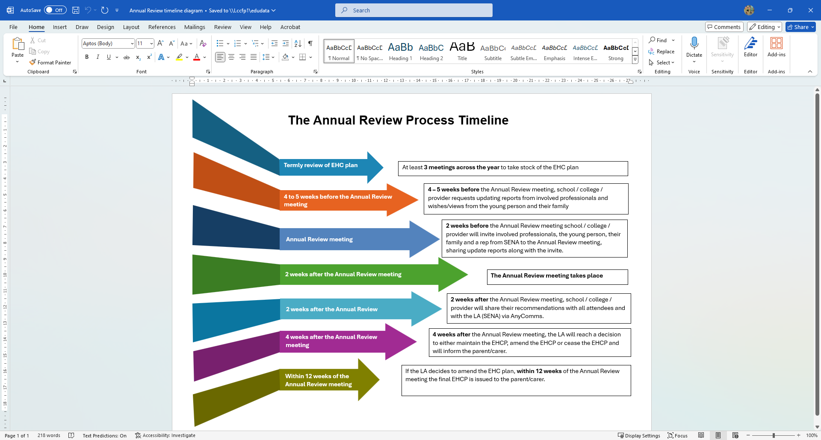

Significant periods for phase transfers (taken from SEND Code of practice):
Early years provider to school / Infant school to junior school / primary school to secondary school
- The review should be completed within the autumn term to enable the review and amendments to be completed by 15th February
Secondary to a post-16 setting or apprenticeship
- The review should be completed within the autumn term to enable the review and amendments to be completed by 31st March
Consideration needs to be given to college course application deadlines within this process.

What to do before the Annual Review meeting

Contributors to the review
When issuing invites to the review meeting all advice and information relevant to the current EHCP must be shared with attendees so that updates can be prepared and provided. Please indicate here what advice and information have been shared prior to the meeting and who provided updated information for this review.
Additional blank rows have been included to add in any additional roles that are providing advice / information
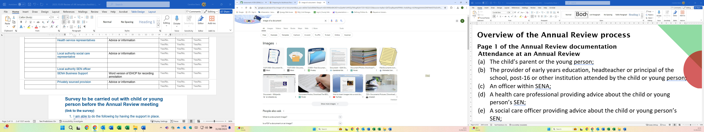Refer to Annual Review guidance document – pages 4 and 5
Action required | Associated document | Date
Health requesting schools to email: LPT.EHCAR@nhs.net | Health professional contribution to annual review (Word document) | 8 weeks prior to Annual Review meeting

Full list of contributors (not all relevant for every young person’s review)
Name | ROLE  (Educational Psychologist,  Therapist, Child/Young Person,parent) | Information required | Advice or information requested | Invited to Annual Review meeting | Advice or information received  received
 | Child or Young person | Voice (see One Page Profile on page 6) | Yes/No. | Yes/No. | Yes/No.
 | Parent/carer | Voice (see One Page Profile on page 8) | Yes/No. | Yes/No. | Yes/No.
 | Educational setting | Costed provision map (if readily available – required for change of placement) | Yes/No. | Yes/No. | Yes/No.
 | Educational setting | Current EHCP in use | Yes/No. | Yes/No. | Yes/No.
 | Educational setting (Careers Guidance Co-ordinator) | Updated careers guidance | Yes/No. | Yes/No. | Yes/No.
 | Education representatives (include tutors) | Advice or information | Yes/No. | Yes/No. | Yes/No.
 | Educational setting | Record of attendance | Yes/No. | Yes/No. | Yes/No.
 | Educational setting | Individual Health Care Plan | Yes/No. | Yes/No. | Yes/No.
 |  |  | Yes/No. | Yes/No. | Yes/No.
 | Health service representatives | Advice or information from LPT / UHL advice givers | Yes/No. | Yes/No. | Yes/No.
 |  |  | Yes/No. | Yes/No. | Yes/No.
 |  |  | Yes/No. | Yes/No. | Yes/No.
 | Local authority social care representative (see note at bottom of table) | Advice or information from Family Help staff, e.g. SEND Family Support Workers, Keyworkers; Children’s Social Workers; Young Adult Disability team; Adult Social Workers | Yes/No. | Yes/No. | Yes/No.
 |  |  | Yes/No. | Yes/No. | Yes/No.
 |  |  | Yes/No. | Yes/No. | Yes/No.
 | Local authority SEN officer |  |  |  | Yes/No.
 | SENA Business Support | Contact to request a Word version of current final EHCP for recording annotation | Yes/No. | Yes/No. | Yes/No.
 | Privately sourced provision | Advice or information | Yes/No. | Yes/No. | Yes/No.
 |  |  | Yes/No. | Yes/No. | Yes/No.

- When establishing whether families are working with care services, schools and post-16 provision may not be aware of the wider spectrum of support that a family may be in receipt of – families on a Child in Need and Child Protection Plan will be known. Families may receive short-term intervention through Family Help and may have a Key Worker or a Family Wellbeing Worker. If in receipt of a Short Break, the family may have a SEND Family Support Worker or a Social Worker, with a likely review on an annual basis. A self-assessment pilot is in place, so not all families have access toa worker. Families may not always know the term Short Break, so other terms that they may be familiar with are direct payments, personal assistant or have regular sessions at a service (e.g. FTM Dance, SENSE) which are provided for by the LA.

Work prior to the Annual Review
Survey to be carried out with child or young person before the Annual Review meeting
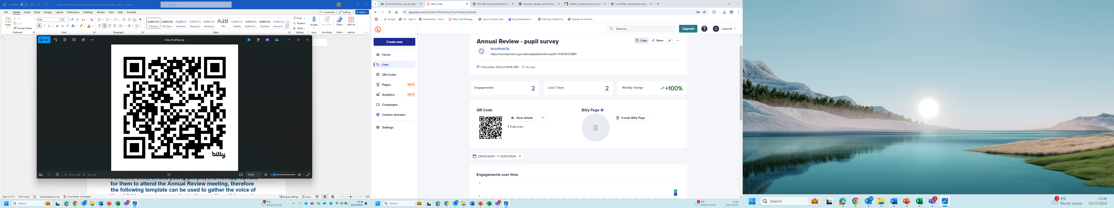 https://bit.ly/41aqV2p
Questions within the survey:
- What type of school do you go to?
- Primary school
- Secondary school
- Special school
- Other

- What does the support you have at school help you to do?
Free text

- How often, if at all, do you feel that you are getting the right support to help you at school?
All of the time Most of the time Some of the time Not very often Never Don’t know

- Is there anything else you would like to say about the support you have at school?
Free text.

This response was provided by the:
- Me – the child or young person
- A representative on behalf of the child or young person
N.B. This information is being used as part of the Accelerated Progress Plan and reporting on the SEND & Inclusion Strategy.

Collating voice for section A
For some young people, it is not appropriate for them to attend the Annual Review meeting, therefore the following information / template can be used to gather the voice of the young person prior to the meeting. It is good practice to share the contents along with other contributions.
See One Page Profile for young person
Refer to Annual Review guidance document – pages 15 and 16 regarding Preparation for Adulthood and Careers Guidance
Refer to Annual Review guidance document – pages 8, 9 and 10
See One Page Profile from parent/carer (send out - to be completed prior to Annual Review meeting)

During the Annual Review meeting

Name of School
Pupils Name
Date of Birth | Click or tap to enter a date. |  | Date of AR | Click or tap to enter a date.
Address
Year Group |  | N/C Year Group Educated

Looked After Child |  | Care Authority

Who attended the meeting?
Name | ROLE  (Educational Psychologist,  Therapist, Child/Young Person,parent) | Attended Yes / No
 | Child or Young person | Yes/No.
 | Parent/carer | Yes/No.
 | Setting, school, college representative | Yes/No.
 |  | Yes/No.
 | Education representative (include tutors) | Yes/No.
 |  | Yes/No.
 | Health service representative | Yes/No.
 | Local authority social care representative, e.g. Family Help – SEND Family Support Worker, Keyworker; Children’s Social Worker, Young Adult Disability Social Worker; Adult Social Worker | Yes/No.
 | Local authority SEN officer | Yes/No.
 | Privately sourced provision | Yes/No.
 |  | Yes/No.

Type of Annual Review
Scheduled Review ☐ Early Review ☐
Transition Review ☐ Updated Plan Following Tribunal ☐

Primary category of need (Taken from SEND Code of Practice)
Cognition & Learning ☐ Social Emotional and Mental Health ☐
Communication & Interaction ☐ Sensory and Physical ☐

Primary need (Taken from School Census)
Autism Spectrum Disorder ☐ Hearing Impairment ☐
Moderate Learning Difficulty ☐ Multi-sensory Impairment ☐
Other difficulty / disability ☐ Physical Disability ☐
Profound and Multiple Learning Difficulty ☐
Severe Learning Disability ☐
Social Emotional and Mental Health ☐ Specific Learning Difficulty ☐
Speech, Language or Communication Difficulty ☐ Visual Impairment ☐

Refer to Annual Review guidance document – page 10

If the child or young person contributed through alternative means, please include the method used:

If the child/young person did not attend or contribute to the review, please provide reasons why and what support has been provided to ensure their views have been gathered and included:

Recording the conversation
Refer to Annual Review guidance document – pages 7, 8, 9 and 10

Please note the key points discussed during the discussion in the notes section.
Taken from the SEND Code of Practice:
9.177 The meeting must focus on the child or young person’s progress towards achieving the outcomes specified in the EHC plan, and on what changes might need to be made to the support provided to help them achieve those outcomes, or whether changes are needed to the outcomes themselves.
Also consider:
- Preparation for Adulthood (or the future)
- Aspirations – what I would like to achieve?

Section A - notes

- Continued relevance of any historical / sensitive information.
- Contribution from child / young person and parent/carer.
- Information that gives the views, interests and aspirations of the child/ young person and their parents/ guardians.

Refer to Annual Review guidance document – pages 7 to 10 and 15 to 16
Using the information collected from the young person, complete the following sections
The views of the young person
Actions relating to aspirations:
Please consider: transport needs, health care, personal care, living arrangements, support ratios, personal budgets, social care provision)
My aspirations: | How can I help myself to do this?
- Education, employment, training
- transport needs,
- health care, e.g. independence in medication
- personal care,
- future living arrangements,
- support ratios,
- social care provision, e.g. Short Breaks, direct payments
Support required and what this would look like:
- Adult support
- Independence
- Break / lunchtimes

Actions relating to aspirations:
Please consider: transport needs, health care, personal care, living arrangements, support ratios, personal budgets, social care provision)
The views of parents or carers
Our aspirations for the young person: | How can we help them to do this?
- Education, employment, training
- transport needs,
- health care, e.g. independence in medication
- personal care,
- future living arrangements,
- support ratios,
- social care provision, e.g. Short Breaks, direct payments

Service responses - education
What will the school need to do and plan for?
- This section should make clear the actions, timescales and responsibilities.
- It should cover transition from school to further learning, and from child to adult services.
How will the school help the young person to become more independent?
How will the school help the young person to be active in the school community?
How will the school help the young person to take on new roles?
How will the school help to develop skills, knowledge and experience to be able to achieve aspirations?

Which agencies should be involved in the future?

Other services, e.g. health / social care
What actions need to be taken to make any appropriate services as accessible as possible for the young person?
Universal Health Services: e.g. GP, dental, family planning
Specialist Health Services: e.g. speech and language, occupational therapy, physiotherapy
Technological support: e.g. software, equipment, communication aids etc
Access to social care services: e.g. home care support, short term breaks, direct payments, etc.?
Access to Benefits
Housing and adaptation needs
Community, leisure and voluntary services: e.g. MENCAP, Scope, SENSE

Actions to be taken following the meeting | Responsible Person/Role | By when?

Who is leading on monitoring the above action points?

Expected school leaving date?

If the young person is living out of Leicestershire (e.g. at residential college, school or elsewhere) who should work together to assist future return to the county?

Refer to Annual Review guidance document – page 11 to 13
Notes on the discussion for sections: C & G, D & H1/H2
It is helpful to record:
- Where there is agreement
- Where there is disagreement
- Where the disagreement has been resolved
- Where the disagreement has not been resolved

Refer to Annual Review guidance document – pages 13 and 14
Section E:
Cognition and Learning
Outcomes in EHCP | Progress made against the outcome | Outcome remains appropriate or Proposed New Outcome
New outcome required?
Section E:
Communication and Interaction
Outcomes in EHCP | Progress made against the outcome | Outcome remains appropriate or Proposed New Outcome
New outcome required?
Section E:
Social, Emotional and Mental Health
Outcomes in EHCP | Progress made against the outcome | Outcome remains appropriate or Proposed New Outcome
New outcome required?
Section E:
Sensory and Physical
Outcomes in EHCP | Progress made against the outcome | Outcome remains appropriate or Proposed New Outcome
New outcome required?
Notes on needs and provision (Consider any new needs / provision required to meet outcomes)

Refer to Annual Review guidance document – page 17
Section J – notes
A personal budget (or a direct payment) that links any funding provided with specific outcomes of the EHC plan. This can either be from:
- Education
- Health
- Social care (likely to be a direct payment)

Has a personal budget been discussed? | Yes/No.
Request information for a personal budget  Education  Health  Care | Yes/No.  Yes/No.  Yes/No.

Annotating the EHCP - guidance for changes to the EHCP
Please note: All edits must be on the word document of the EHCP. If you only have a PDF version, please contact SENA for them to reissue as a word document. Handwritten edits will not be accepted moving forward.
At Annual Review, any amendments to the EHCP should be annotated as follows:
Any proposed deletions MUST be shown by strikethrough
Any proposed additions to the EHCP/Statement MUST be shown in Bold
EXAMPLE
Mary uses her voice all the time when she is communicating. She uses signs to communicate at home and will imitate what she hears when language is simplified and directed to her. Mary will switch between sign and spoken language according to who she is communicating with. Mary is a natural communicator. She is always keen to share her news and is confident in her ability to do so. She will happily talk to people throughout the school and will repeat what she has said to ensure understanding. Mary can have conversations now and will ask questions to probe for more information.
Mary is now joining signs together and is able to tell you simple things that have happened. Mary is constantly learning new signs and is observant of hand shape and position. She enjoys singing which helps bring a flow and fluency to her signing. Mary will now place time markers in her signing when retelling events and she understands and can use prepositions in sign. Her signed vocabulary is quickly expanding and she is visually very alert. She has some recognisable spoken words to a familiar listener and lots of speech like vocalisation. She can follow simple verbal and familiar instructions when in context. Mary is a natural communicator and is keen to get her message across
N.B. Amendments are not to be made on the hours or the funding.
Advice on reviewing an EHCP that has not been amended
Consider the amendments to the EHCP made in the previous year/s during the discussion. However, add amendments onto the current Word version of the EHCP (the last issued final EHCP). This will make it easier for Case Managers to consider the requested amendments.
Refer to Annual Review guidance document – page 18 and 19

Conclusion of this review (please tick ONE)

- Keep the plan as it is.

- The outcomes have been achieved so it is recommended that the LA should cease to maintain the EHCP.

Reason for maintaining or cease to maintain:
………………………………………………………………………………………………

- Amendments are recommended (please see annotated EHCP).
Other additional information:

- Parent/carers would like consideration for a different type of educational setting.
………………………………………………………………………………………

- It is recommended that the LA carry out a new statutory re-assessment of the pupil’s needs due to significant changes.

Signed by Head Teacher or head of setting:

Name (Printed): | Date:

Please indicate the person who hosted the review meeting:
Name: (Printed)
Role in School:

What happens next
Refer to Annual Review guidance document – page 6
This report, together with other documents that are editable, e.g. in Word rather than a pdf or scanned, should be sent by secure electronic transfer (AnyComms+) to the SEN Assessment Service as soon as possible (within 2 weeks – SEN Code of Practice 9.176). It is useful to ensure that documents are clearly titled as to what they are and include the date of the Annual Review and pupil name, e.g. 230329 Sam Thompson Annual Review Report; 230329 Sam Thompson AR Pupils Views
Following receipt of this Annual Review documentation, the SEN Assessment Service will consider the amendments and recommendations.
To ensure the correct documentation is provided to SENA, please complete this checklist:
Have you attached the following with your submission to SENA?

Notes of the conversation made during the annual review meeting (this template) | Yes ☐ No ☐
Advice and information sent out before the meeting:
Child or Young person voice | Yes ☐ No ☐
Parent/carer voice | Yes ☐ No ☐
From Educational setting (setting, school, college)
Cost of provision map | Yes ☐ No ☐
Record of Attendance | Yes ☐ No ☐
Evidence of attainment and or progress made over the last 12 months (unless an early review) | Yes ☐ No ☐
Individual Health Care Plan | Yes ☐ No ☐  N/A ☐
Annotated EHCP | Yes ☐ No ☐
Progress towards achieving the outcomes? | Achieved ☐  Partly achieved ☐ None achieved ☐
Other appropriate school information / report (include tutors) | Yes ☐ No ☐  N/A ☐
Health service information / report | Yes ☐ No ☐  N/A ☐
Local authority social care information / report | Yes ☐ No ☐  N/A ☐
Privately sourced provision reports | Yes ☐ No ☐  N/A ☐
Preparing for Adulthood (PFA)
Preparation for Assessment been discussed? | Yes ☐ No ☐ At a minimum from year 9, earlier if appropriate
Careers Guidance
Discussion on post-16 options – 6th form, college, apprenticeship, internship, etc. | Yes ☐ No ☐ Year 11
Annual Review documentation signed by Headteacher (will also accept photo signature pasted onto document, electronic signature but not a typed name) | Yes ☐ No ☐

