One Page Profile for child – to be completed prior to Annual Review meeting
Name of pupil: | Completed by: | Date:

How do you prefer to communicate?  Please indicate by adding bold or highlight relevant method | 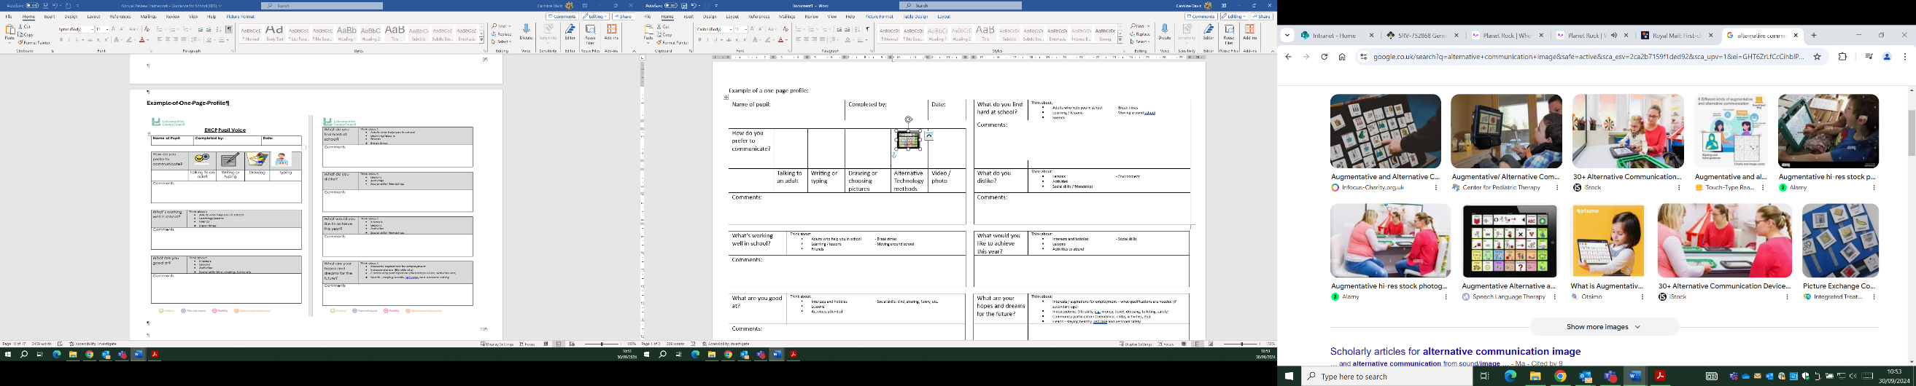 | 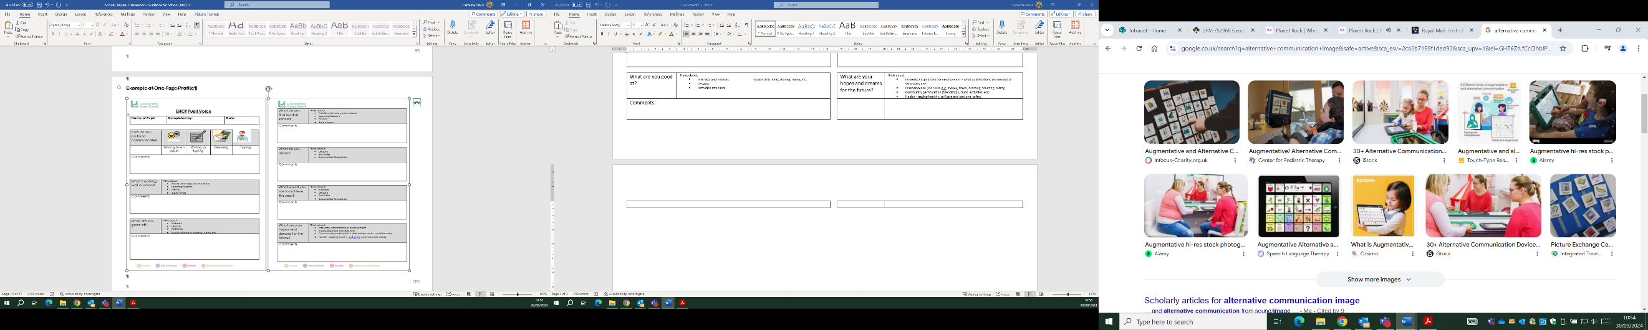  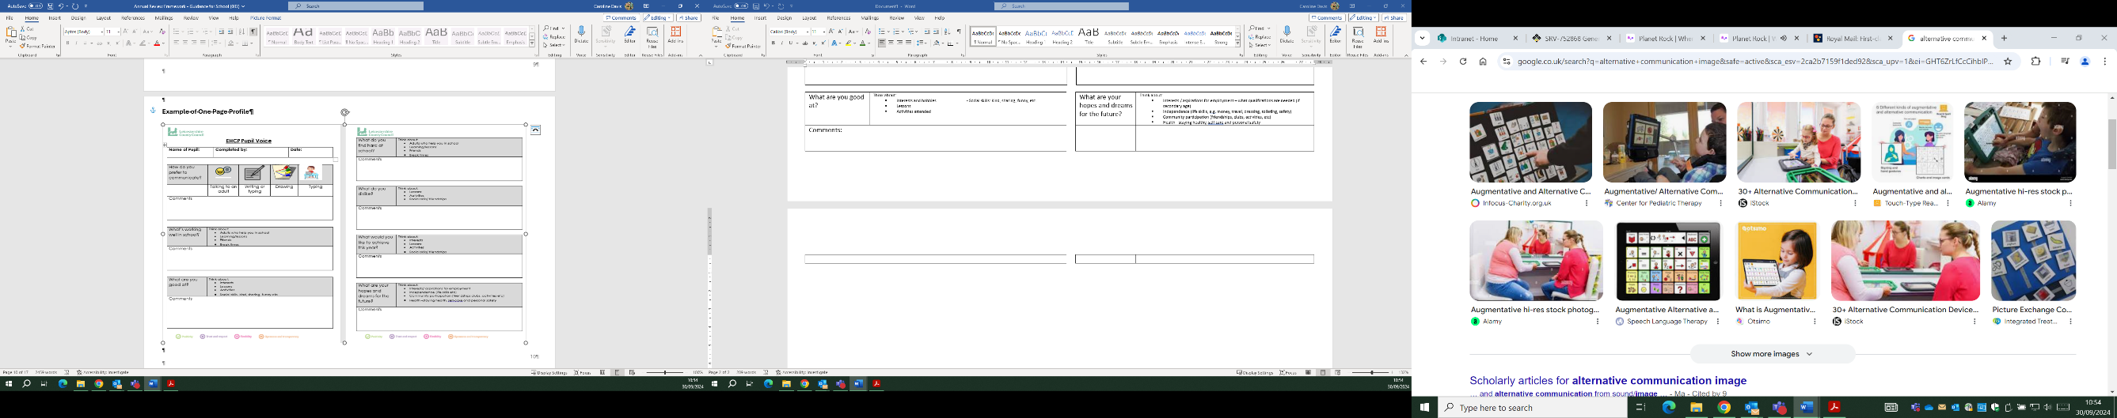 | 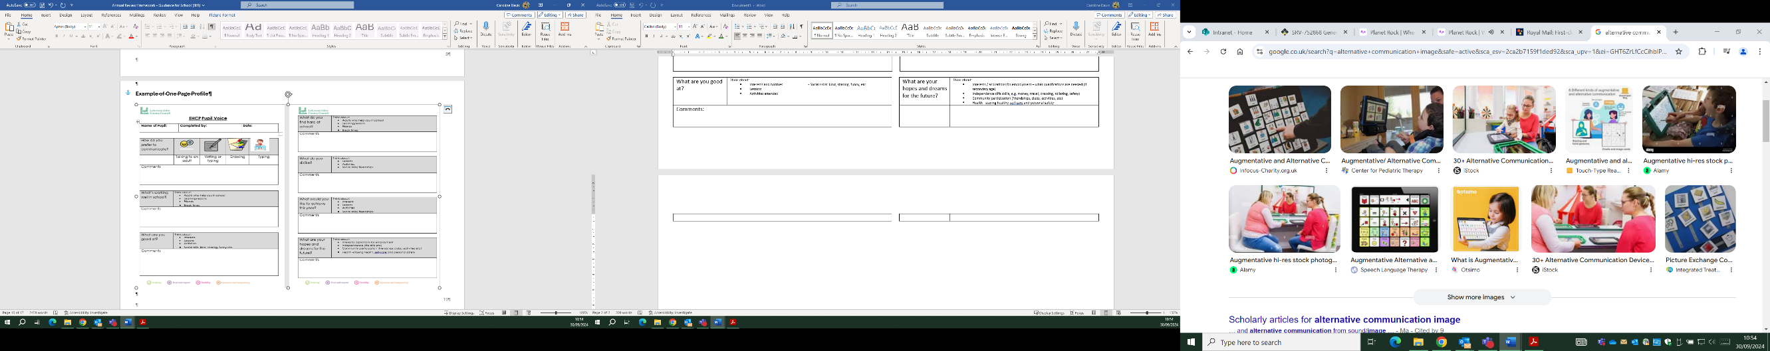 | 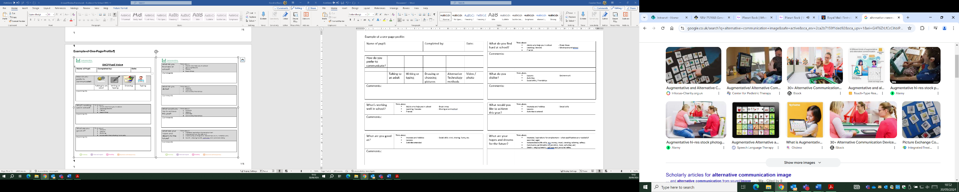 | 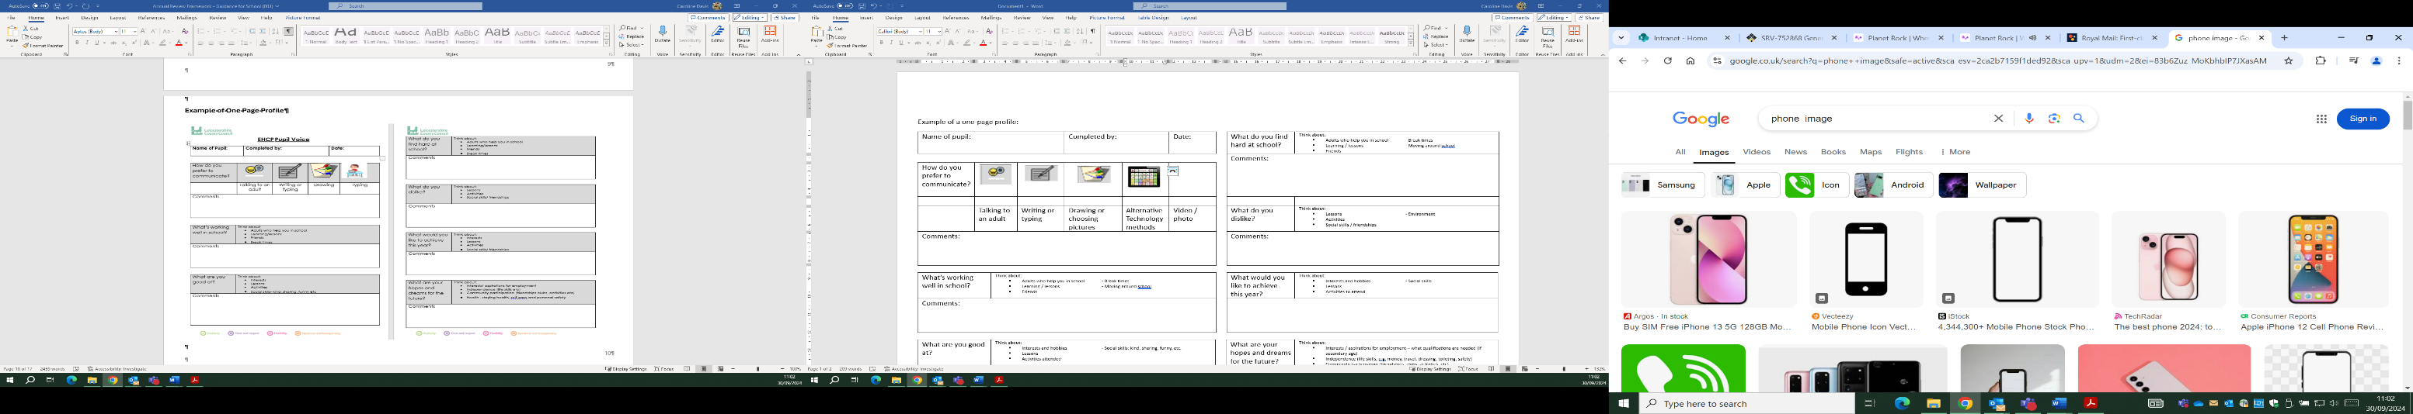
 | Talking to an adult | Writing or typing | Drawing or choosing pictures | Alternative Technology methods | Video / photo
Comments:

What is working well in school? (Think about: Adults who help you in school; Break time; Learning / lessons; Moving around school; Friendships)

What does the support you have at school help you to do?

What makes me happy (interests, passions and skills that are important to me): (Think about: Interests and hobbies; Social skills: kind, sharing, funny, etc. Lessons; Activities attended)

This is how I would like to supported (other things that I would like people to know): (Think about: Adults who help you in school; Break times; Learning / lessons; Moving around school; Social skills / Friendships; access to activities)

Things that I do in my local community and how I am supported to do them: (Think about: Activities attended; Social skills / friendships; Support from family/friends; Short Breaks / direct payment / personal assistant)

Things that I would like to do but I can’t: (Think about: In school; At home’ Near where you live)

What is getting in the way of being able to do some things that I would like to be able to do: (Think about: Skills needed; Adult support required: Transport; Money)

What would I like to be able to achieve this year: (Think about: Interests and hobbies; Social skills; Lessons; Activities to attend)

This is what I want for the future (hopes and dreams): Think about:
- Transition to school, other setting, college – choosing GCSE or A levels; vocational study, apprenticeship or a supported internship
- Interests / aspirations for employment – what qualifications are needed (if secondary age)
- Independence (life skills, e.g. money, travel, dressing, toileting, safety)
- Community participation (friendships, clubs, activities, etc)
- Health - staying healthy, self care and personal safety

