One Page Profile – to be completed prior to Annual Review meeting
Name of pupil: | Completed by: | Date:

How do you prefer to communicate?  Please indicate by adding bold or highlight relevant method | 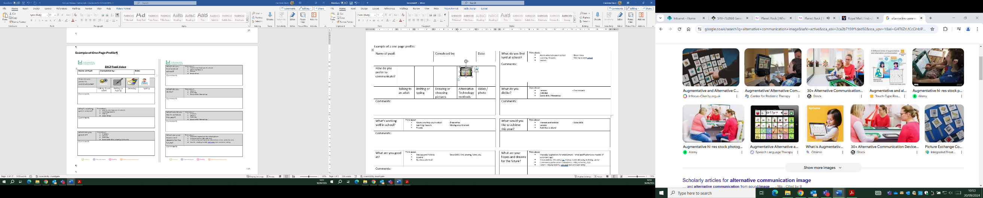 | 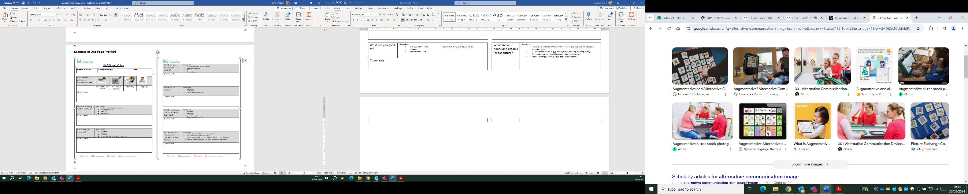  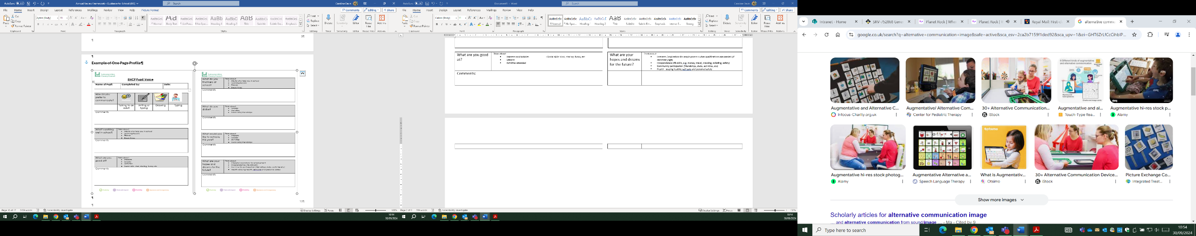 | 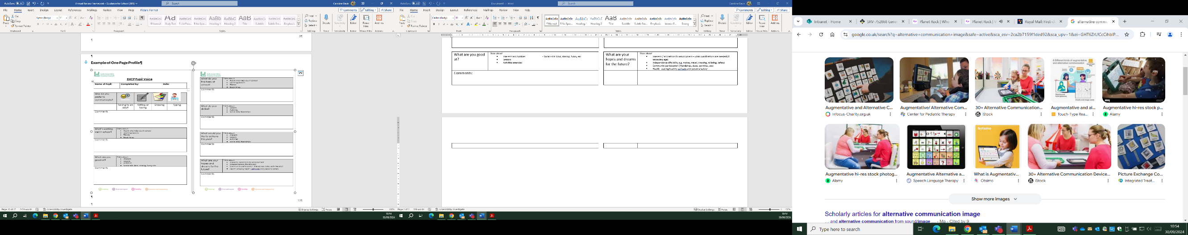 | 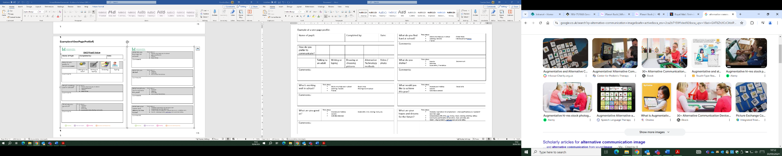 | 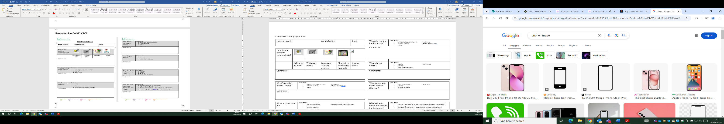
 | Talking to an adult | Writing or typing | Drawing or choosing pictures | Alternative Technology methods | Video / photo
Comments:

What is working well in school:
Think about:
- Adults who help you in school;
- Break time;
- Learning / lessons;
- Moving around school;
- Friendships
What does the support you have at school help you to do?
What makes me happy (interests, passions and skills that are important to me):
Think about:
- Interests and hobbies;
- Social skills: kind, sharing, funny, etc.
- Lessons;
- Activities attended
This is how I would like to be supported (other things that I would like people to know):
Think about:
- Adults who help you in school;
- Break times;
- Learning / lessons;
- Moving around school;
- Social skills / Friendships;
- Access to activities
Things that I do in my local community and how I am supported to do them:
Think about:
- Activities attended;
- Social skills / friendships;
- Support from family/friends
- Access to a Short Break
Things that the health service support me with and how this is helping me:
Think about, for example:
- CAMHS
- Community Paediatrician
- Speech and Language Therapy
- Physiotherapy
Things that I would like to do but I can’t:
Think about:
- In school;
- At home
- Near where you live
What is getting in the way of being able to do some of these things:
Think about:
- Skills needed;
- Adult support required:
- Transport;
- Money
What would I like to do this year:
Think about:
- Interests and hobbies;
- Social skills;
- Lessons;
- Activities to attend
Aspirations

Current Careers Guidance
- Support provided to consider future employment opportunities and what options are available
- Qualifications required for potential career options
My aspirations and hopes and dreams for the future (this is what I want for my future):
- Transition to school, other setting, college – choosing GCSE or A levels; vocational study, apprenticeship or a supported internship
- Interests / aspirations for employment – what qualifications are needed (if secondary age)
- Independence (life skills, e.g. money, travel, dressing, toileting, safety)
- Community participation (friendships, clubs, activities, etc)
- Health - staying healthy, self-care and personal safety
What can I do to meet my aspirations?

