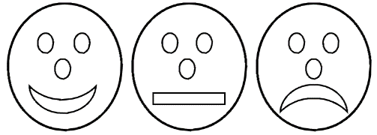

Draw a picture of a Red, Orange and Green Traffic light.

Or draw you crossing the road safely. Remember the road safety hand; stop, look, listen, think, hold-hands.

**Stop, Look, Listen, Think, Hold Hands**