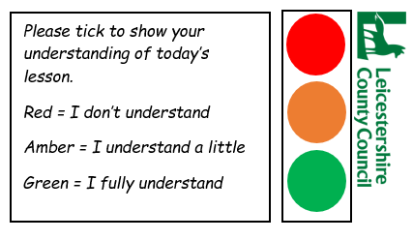LO - To share how to keep safe whilst crossing the road.

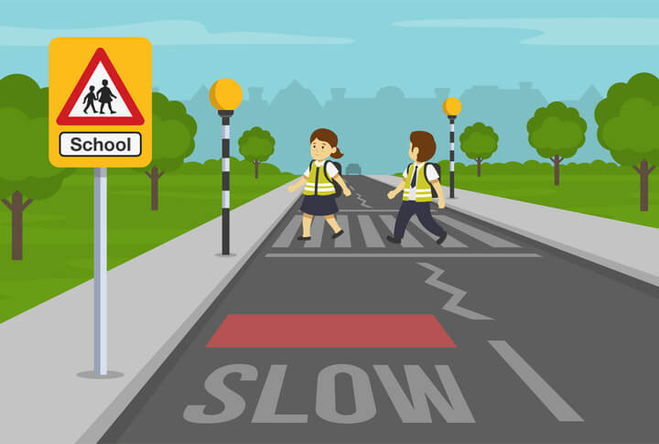

1. Firstly: Find a safe place to _ _ _ _ _ where you can see all around.

2. You then need to _ _ _ _ with your toes behind the kerb.

3. Look and _ _ _ _ _ _ for traffic coming.

4. If traffic is coming do not cross, _ _ _ _ and let it pass.

5. When there is no traffic and _ _ _ _ _ , it is safe walk straight across?

6. Keep _ _ _ _ _ _ _ , listening and thinking while you cross.

think looking listen stop wait cross