One page profile for child – to be completed prior to Annual Review meeting
Name of child: | Completed by: | Date:

How do you prefer to communicate?  Please indicate by adding bold or highlight relevant method | 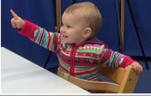 |   This Photo by Unknown Author is licensed under CC BY-NC-ND | 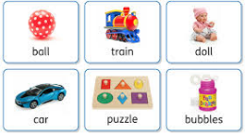 |  | ?
 | Gestures and body language, | Signing | Using objects/pictures | Through my behaviour | other
Comments:

What is working well in setting? (Think about: Adults who help you in setting ; settling in, meal times, play skills; Moving around setting; Friendships)

What does the support you have help you to do?

What makes me happy (interests, passions and skills that are important to me): (Think about: Interests and hobbies; Social skills: favourite activities)

This is how I would like to supported (other things that I would like people to know): (Think about: Adults who help you in setting; mealtimes; playing; Social skills / Friendships; access to activities)

Things that I do in my local community and how I am supported to do them: (Think about: Activities attended; Social skills / friendships; Support from family/friends;

Things that I would like to do but I can’t: (Think about: In setting; At home’ Near where you live)

What is getting in the way of being able to do some things that I would like to be able to do: (Think about: Skills needed; Adult support required:)

What would I like to be able to achieve this year: (Think about: Interests and hobbies; Social skills, self help)

This is what I want for the future (hopes and dreams): Think about:
- Transition to school, other setting,
- Independence (life skills, e.g.dressing, toileting, safety)
- Community participation (friendships, clubs, activities, etc)
- Health - staying healthy, self care and personal safety

