VIRTUAL SCHOOL SUMMER READING CHALLENGE

Can you complete all our reading challenges during the
summer holidays?
Everyone who enters will receive a £5 voucher
and the best entry will win a £10 voucher!

Email your completed form to virtualschool@leics.gov.uk
or send it to:

Leicestershire Virtual School,
Room 500,
County Hall,
Glenfield
Leicester
LE3 8RF

Your name __________________

Your age ___________________
Read a book where the main character is an animal.
I read

Read a recipe and make something.
I made

Read a story to a pet or a cuddly toy.
I read
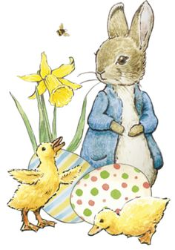

Find a book title that starts with the first letter of your name.

The book is called

By

Listen to an audio book.

I listened to

Read a book with dinosaurs in it.
I read

Dress up as your favourite character.
I dressed up as

Draw a picture of your favourite character from a book.

Read a comic or magazine.
I read

Read a poem or write a poem

I read

Or I wrote this poem

Write a book review.
Title:
By:
I liked reading this book because

Act out your favourite story.
My favourite story is

I played the part of

Retell a story to someone at home.

I retold a story to

Listen to someone read to you.
The person who read to me was

They read

Make a den in the garden as a reading base for you and your toys.

Send a photo of your den with your entry

Make a list of your favourite books, poems or magazines.

1)

2)

3)

4)

5)

WELL DONE! YOU HAVE COMPLETED THE SUMMER READING CHALLENGE!
NOW SEND THIS COMPLETED FORM BACK TO GET YOUR £5 VOUCHER
HAVE A GREAT SUMMER!

