Can you complete our reading challenge?
Leicestershire Virtual School Secondary Summer Reading Challenge

Everyone who enters will receive a £5 voucher and the best entry will
win a £10 voucher!

Email your completed form to virtualschool@leics/gov.uk
or send it to:
Leicestershire Virtual School,
Room 500,
County Hall,
Glenfield
Leicester
LE3 8RF

Entries should be received by 31st August 2020

Your name __________________ Your age ___________________

Happy reading!
- Find a poem that makes you laugh.
Title:
Author:

- Find an inspirational or funny quote in a book. Write it down, decorate it and put it somewhere you will see it every day. Attach a photo of it.

- Read a non-fiction book and record 4 fascinating facts below:

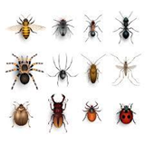

- Read the first line of several books and write down your favourite.
Title:
First line:

- Draw your favourite character from a book.

- Read a graphic novel or comic.
Title:
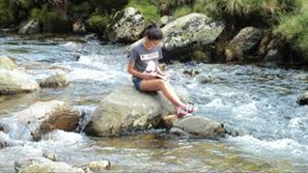
Author:
- Take a photo of yourself reading in a strange place (safely!)

- Listen to an audio book.
Title:
Author:

- Find a good quote from a book and use it in everyday conversation – see if anyone notices!

Quote:

Book:

10. Cook something delicious from a recipe book. Attach a photo of it.

- Choose a book for your carer to read and read one that they recommend to you!
Title:
Author:

- Read a book or a poem to somebody else.
Title:
Author:

- Read a book based on a film you like or watch the film of a book you have read.

Title of the book or film:

- And finally…which book would you recommend to us and why?
Title:
Author:
Reason for recommending this book:

Thank you for taking part!

