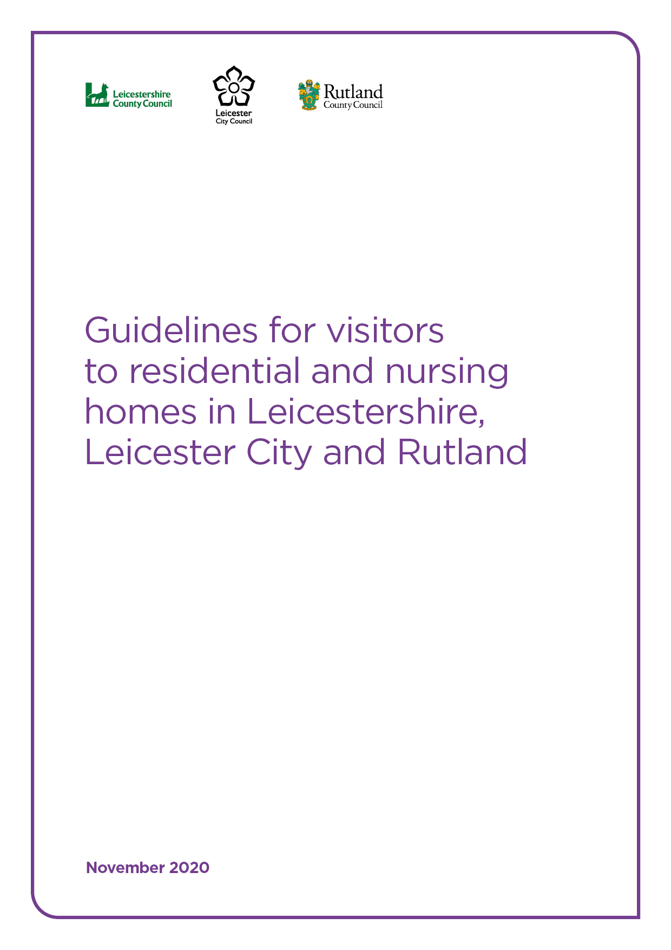
Guidelines for visitors to residential and nursing homes in Leicestershire, Leicester City and Rutland

Introduction
On 15 October 2020, Government updated its guidance on policies for visiting arrangements in care homes. The guidance highlighted the need for Directors of Public Health and care providers to ensure policies for visiting arrangements and decisions are based on a dynamic risk assessment and that risk is minimised wherever possible.
As of 1st December 2020, national guidance was updated to incorporate rapid (lateral flow) testing. This enables care homes to test visitors prior to visiting residents
In line with national guidance, introduced in December 2020/early January 2021, close contact indoor visits could not to take place during the lockdown period introduced in January 2021 see extract and link to guidance below.
‘Visits to care homes can take place with arrangements such as substantial screens, visiting pods, or behind windows. Close-contact indoor visits are not allowed. No visits will be permitted in the event of an outbreak.’
https://www.gov.uk/guidance/national-lockdown-stay-at-home#care-home-visits
From 8th March 2021 further government guidance was introduced for care homes on visiting arrangements, these guidelines supersede earlier versions. The main change that this guidance brings, is allowing a single regular visitor to be nominated for each care home resident, and also the nomination of an essential care giver for residents, where this is appropriate. In line with this new guidance (link below), lateral flow testing will need to be in place prior to the visit, as well as the adherence to infection prevention and control measures (IPC), use of PPE and social distancing.
https://www.gov.uk/government/publications/visiting-care-homes-during-coronavirus/update-on-policies-for-visiting-arrangements-in-care-homes
Outside of the above arrangements, other care home visits can continue to take place with arrangements such as substantial screens, visiting pods, or behind windows.
No visits will be permitted in the event of an outbreak, except for essential visits.

Our priority remains to prevent infections in care homes and protect staff and residents from the avoidable risk of contracting COVID-19 which can have a devastating impact if it spreads through a care home. While the vaccine is bringing much needed hope and protection, until more is known about its impact on transmission, residents and visitors should continue to adhere to all the infection control measures that are in place now.
However, we also recognise the importance of allowing care home residents to safely meet their loved ones for their own wellbeing as well as the wellbeing of friends, family and staff. We also recognise that each resident and care home is unique therefore a one size fits all approach is not suitable.
The following guidance offers an approach that care homes can use to ensure that all the necessary and appropriate precautions are in place to protect both the health & safety of those being cared for and the staff employed in the service.
General Principles
This guidance applies to visits into care homes. It does not apply to visits out of care homes (e.g. to visit a family home) or visits in supported living settings. Guidance for visits out of a care home is available here: https://www.gov.uk/government/publications/arrangements-for-visiting-out-of-the-care-home/visits-out-of-care-homes. Guidance for visits in supported living settings is available here: https://www.gov.uk/government/publications/supported-living-services-during-coronavirus-covid-19/covid-19-guidance-for-supported-living#visitors-and-support-bubbles.
Given the significant vulnerability of residents and the increased risks visiting will present, care homes should continue to encourage all staff to be part of the regular testing programme where possible. Regular testing acts as an early warning system and will support care homes to both manage and reduce the risk of spreading the virus. Results from regular testing will also ensure risk assessments are well informed.
The national guidance includes the use of rapid (lateral flow) testing. This enables care homes to test visitors, prior to visiting residents. Rapid testing will help to reduce risks for residents, however it will not completely remove the risk of infection. It will be important that even when visitors have received a negative test, that the usual measures around infection prevention and control (IPC), wearing of appropriate personal protective equipment (PPE), social distancing and good hand hygiene are robustly adhered to. The deployment of rapid testing is therefore a useful supplement to be used, in addition to, the existing LLR and national guidelines around care home visiting.
Another early warning system is the information provided through the Capacity Tracker. It is vital that all care homes regularly (at least weekly) complete the Capacity Tracker as this provides a timely and rich source of information to help inform the local picture of COVID-19 infection and its subsequent impact on care home visits.
We recognise that it may be necessary for care homes to take a bespoke approach to visiting in order to meet the needs of a resident or group of residents while also taking into account the layout and facilities within the home. Care planning, visiting policy and risk assessments will need to reflect this and every opportunity should be taken to involve residents and their families when developing these. See Appendix A for a good practice example of a risk assessment template.
The visiting policy should be made available and/or communicated to residents and families, together with any necessary variations to arrangements due to external events.
All decisions should take into consideration obligations under the Equality Act 2010, the Human Rights Act 1998 and Mental Capacity Act (2005), as applicable. Providers must also have regard to the DHSC ethical framework for adult social care.
Essential visits such as for residents approaching the end of their lives should continue in all circumstances. This has remained unchanged since the beginning of the pandemic. Further guidance on the definition of end of life can be found in Appendix B.
In addition to undertaking a risk assessment for introducing visitors to the care home, a clear pathway with triggers for re-introducing visiting restrictions should also be developed. Examples of circumstances when this will apply include:
- An active COVID-19 outbreak (2 or more cases within a 14-day period) in the care home. Non-essential visits should stop in these circumstances until such time that the outbreak has been brought under control or until such time that the care home has recovered. A recovered outbreak is defined as 28 days or more since the last suspected or confirmed case reported. In such cases, alternative means of maintaining contact between residents and their loved ones should be clearly set out within the visiting policy. There may certain circumstances when visiting can be reintroduced before the 28-day period has elapsed. This will be determined on a case by case basis by the local authority public health department or by Public Health England (East Midlands).
- When a local risk assessment identifies the need for visiting restrictions to become necessary e.g. an upward trend in COVID-19 cases in the local area or a change to the COVID-19 local alert level. Where this situation arises, the care home will be notified directly in a timely manner.
The Director of Public Health cannot review all care home risk assessments and visitor policies but does retain the right to request and review them if there are any concerns. Please review the full national guidance to help you complete your risk assessment and review your visitor policy.

Types of visits
There are several ways in which visiting is possible. These are outlined below and should be considered in the order listed.
- The recent government guidance sets out the arrangements that need to be put in place for single named visitors and essential care givers, the guidance link is here https://www.gov.uk/government/publications/visiting-care-homes-during-coronavirus/update-on-policies-for-visiting-arrangements-in-care-homes

- Consider alternatives to in-person visiting such as video calls or phone calls.

- Where the weather permits, closed window visits should be considered as an alternative way for family and friends to visit loved ones on the basis that appropriate safety arrangements are in place. Given that the window must remain closed, communication aids are likely to be needed. Residents who are isolating for any reason linked to COVID-19 (symptomatic, tested positive or a close contact of a positive case) should only take part in closed window visits if the visit can be facilitated from their own room.

- where risk assessments can support it, visits can be held in the garden/outside area of the home. This includes outdoor visits under an awning, gazebo or open-sided marquee, or visits in another type of outdoor structure which is open-sided and separate to the main building of the care home.

- A dedicated room is made available for visiting with a full risk assessment in place. Considerations for location of the room include the facilitation of; good ventilation, social distancing measures and use of an effective barrier (Perspex screen or floor to ceiling screen) between the resident and the visitor, ease of access by residents, visitor access that is directly from outdoors thereby limiting visitor journeys through residential areas, appropriate acoustics (to avoid the need to raise voices), and regular cleaning in accordance with national guidance.

COVID-19 mitigating measures
In line with national guidance and good infection prevention and control measures, care homes need to ensure the following elements are in place and clearly described to friends and families as part of the care home’s visiting policy.
- Visits must be pre-arranged with the manager/person in charge of the home. This is to support the home to manage the flow of visitors.
- Prior to the visit, visitors should be asked some COVID-19 related questions about their health to ensure no-one with suspected/confirmed COVID-19 infection or a household/close contact of a suspected/confirmed visits the care home. An example form that care homes can use is provided (see Appendix C). Please ensure that measures are in place to store the information in accordance with GDPR regulations and that visitors are fully informed of this.
- The visiting policy of the care home should be shared with residents and families and should include advice that prepares visitors for their visit. This should include tips on how to communicate with their loved one while wearing Personal Protective Equipment (PPE) and expectations with regards to adherence to infection prevention and control measures.
- Discuss with visitors any items they wish to bring with them on their visit, such as a gift. It will need to be something that can be easily cleaned by the care home to prevent cross contamination. For example, it is unlikely that they will be able to bring flowers but a box of chocolates that could be wiped over would be allowed.
- Processes should be in place to ensure visitors are informed that a planned visit may be cancelled or postponed at short notice if the visit cannot be safely facilitated in accordance with national guidance or where the resident is unwell, or in situations where the visitor fails to comply with COVID-19 mitigating measures.
- Care homes should support NHS Test and Trace by keeping a temporary record of visitors in the event contact tracing is required. This link provides a list of information that would be useful to collect: https://www.gov.uk/guidance/maintaining-records-of-staff-customers-and-visitors-to-support-nhs-test-and-trace
- All visits must be overseen by staff to ensure infection control and social distancing measures are adhered to. It is the responsibility of the care home to ensure there is appropriate staffing capacity to manage this.
- Visits must be limited to one single, constant person wherever possible, with an absolute maximum of 2 constant visitors per resident. This is in order to limit the overall number of visitors to the care home and/or to the individual, and the consequent risk of disease transmission from multiple routes.
- Where an internal visit has been risk assessed and measures have been put in place to accommodate this safely, facilities must be in place for visitors to wash their hands with soap and water or to use a hand sanitiser gel when they first enter the property and when they leave. As part of the supervision of the visitor in the home, staff must ensure that this is carried out upon every visit without exception.
- Visitors will need to wear a face covering throughout the visit. The home will need to ensure they have sufficient supplies of surgical face masks as these will need to be provided by the home if visitors do not bring their own. Additional PPE may also need to be considered and offered beyond a face covering if appropriate to the need of their visit. A very small number of residents may have great difficulty in accepting staff or visitors wearing masks or face coverings. In these circumstances, an individualised comprehensive risk assessment should be undertaken. If visors or clear face coverings are available, they can be considered as part of the risk assessment. Under no circumstances should this assessment be applied to the whole care setting.
- During visits inside the care home, it is important that visitors do not come into contact with other residents.
- In order to minimise contact with staff who are providing care, any discussion with staff that is likely to take longer than 15 minutes should take place over the phone after the visit is complete.
- Social distancing between all individuals (visitors, residents, staff, and visitors from other households) must be maintained at all times. There will be some situations where social distancing measures between the resident and visitor will need to be reviewed e.g. where it does not meet the communication needs of the resident. The home will need to consider the availability of additional protective clothing (for example, apron and gloves) if social distancing is difficult to maintain and/or the use of plastic/glass barriers between the resident and the visitor. Where possible, seats should be provided 2 metres apart in the designated area and the visitor advised that these must not be moved. Skin to skin contact such as handshakes or hugs, should be avoided.
- Ensure the designated visitor room is clutter free and cleaned in line with national cleaning guidance for care homes at least daily or more frequently if needed. Particular attention should be paid to frequently touched surfaces /touch points between visits. The visiting space/room must be used by only one resident and visiting party at a time.
- National guidance for care homes does not currently mention children. The home needs to be fair and risk based in their approach and should consider alternatives to visits in person for children.

Further information and guidance
If you have any queries regarding this guidance please contact your relevant local authority:
Leicestershire County Council - enquirylinequality&contracts@leics.gov.uk
Leicester City Council - Caas.carehomes@leicester.gov.uk
Rutland County Council – RISE@rutland.gov.uk

Update on policies for visiting arrangements in care homes: https://www.gov.uk/government/publications/visiting-care-homes-during-coronavirus/update-on-policies-for-visiting-arrangements-in-care-homes

Adult social care: coronavirus (COVID-19) winter plan 2020 to 2021
https://www.gov.uk/government/publications/adult-social-care-coronavirus-covid-19-winter-plan-2020-to-2021

Visitors’ protocol: CPA briefing for care providers https://careprovideralliance.org.uk/coronavirus-visitors-protocol

Full list of local COVID alert levels by area*
https://www.gov.uk/guidance/full-list-of-local-covid-alert-levels-by-area

Appendix A - Example of a Risk Assessment Template

Appendix B – Advice to care homes on visiting arrangement for residents receiving end of life care

Appendix C – COVID-19 screening questionnaire for visitors

Updated: 16.3.21

https://www.gov.uk/government/publications/visiting-care-homes-during-coronavirus/update-on-policies-for-visiting-arrangements-in-care-homes
https://www.gov.uk/government/publications/visiting-care-homes-during-coronavirus/update-on-policies-for-visiting-arrangements-in-care-homes
https://www.gov.uk/government/publications/visiting-care-homes-during-coronavirus/update-on-policies-for-visiting-arrangements-in-care-homes

